**Department of Computer Science**

**Pak-Austria Fachhochschule: Institute of Applied Sciences and Technology, Haripur, Pakistan**

**COMP-112L Object Oriented Programming Lab**

**Final Project Report**

**GROUP MEMBERS:**

**1. AHMED RAZA 2. ZURAIZ KHAN**

**Class: BSCS**

**Semester: 3rd**

**Submitted to: Sir Rafi-Ullah**

**__________________**

**Instructor Signature**

# Project Name: Book Store Management System

**GROUP MEMBERS:**

1. AHMED RAZA

2. ZURAIZ KHAN

## Introduction:

This system can be used as an information management system for the bookstore. Where people can order the books which they want and do not worry about picking it up from the store. We can also make the payment after delivery of the book which will make us feel safe regarding our money. This system allows to create a new account and allows to buy books facilities. It also Provides Advanced searching Facilities.

## Modules:

### Addition of the book:

In this Module, the user can add books to its library.

### Books details:

In This Module, Customers Can see different Books and Can search by their Author name.

### Modify module:

In This Module, Customers Can modify their orders.

### Payment module:

In This Module Customers Can Pay Amount from their Accounts

## Designed Program and its Explanation:

In this final lab project with help of Object-Oriented Programming concepts we designed a program for Book Store Management System.

This program includes an inventory of books after the user upload and update the inventory, the customer can choose the books they want. It shows different option for displaying all the books, for modifying the books and for purchasing the books.

It is a very customer friendly program where you can first check if the book is available, if it is available, you can move forward to your payment module and can purchase the book or anything that you want to do.

Press 1 to add books.

Here we’re adding books and its details through user that we already have in the library.

Press 2 to return to the main screen.

This’ll return to the main Screen as shown in the first picture.

Further to check the list Press 2.

Press ‘’y’’ if you want to buy the book. And if you don’t want to buy press ‘n’ or ‘N’ (This’ll show you again the main screen)

Press 4 to Get the details of the books you purchased.

Press 5 to Modify

Here if the user we want to change the record of the Books details.

Press 6 to Delete

Here if the user wants to Delete the Record of any Book.

Press 7 to EXIT

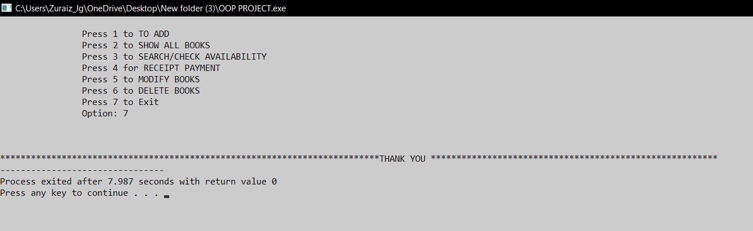

**Conclusion:**

**In this Whole project we’ve implement the concept of OOP & we’ve used the structural programming, further we’ve used Classes concept & after that with help of functions we specify some specific tasks like get_book_details( ), display_book_details( ), display_book_details( ) etc.**

**We’ve implemented some concept of File handling in this project that’s actually creating file at the backend, storing all information that we’ve stored in the program.**

**We also use Switch Statement to call different modules that we want to use in the program.**